Foundation Program English – Rewrite a ‘scene’

**Formative Assessment**

Please note: this will be collected as part of your summative portfolio at the end of the year.

**Objectives**: Students will…

* Rewrite a ‘scene’ of a novel in a different genre/text type, using its conventions effectively
* Explore diverse cultural perspectives in rewriting a scene from a different point of view
* Demonstrate their development of imagination and creativity through self-expression
* Justify stylistic choices of using a particular point of view and genre/text type (rationale)

In this assignment, you will rewrite a ‘scene’ of *The Reluctant Fundamentalist* in a different text type/genre. In doing so, you also need to explore diverse cultural points of view (e.g., how the events of the novel could be viewed differently in different cultural contexts). You can (and should) invent some new details in your narrative (in the process of reimagining the scene from a different cultural point of view), but you should also make sure that your narrative clearly connects to a specific moment (or moments) of Hamid’s novel. In the end, you will write **a 600-800 word narrative** along with a **200-300 word rationale** explaining your choice of text type, generic conventions, and stylistic features for the narrative.

***Proposal Form****: Answer these questions on a Word doc, and then submit on ManageBac.*

* What scene(s) will form the basis for your piece of creative writing?
* What text type/genre will you choose and why?
* What point of view do you intend to use for this piece? Why?
* How will your piece explore different cultural perspectives (e.g., shed light on a scene from a point of view different from that of Changez)?
* **Overall, what are your aims for this piece (i.e., what do you aim to accomplish)?**
* **How will your creative choices (e.g., text type, point of view, style, etc.) enable you to accomplish your aims?**

**Due Dates** will be posted on ManageBac. We will try to use peer editing on Turnitin in order to allow you to get creative, helpful comments on your writing.

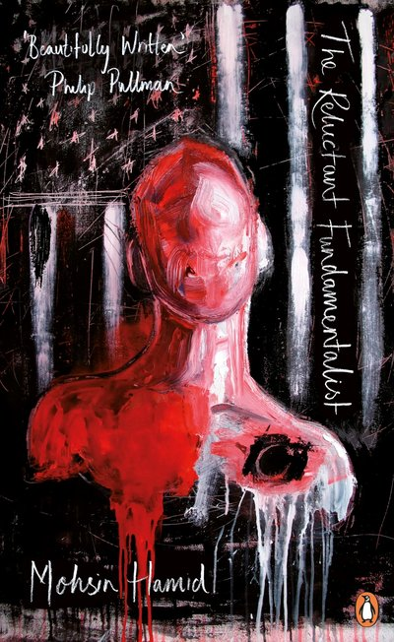

|  |  |  |  |  |  |
| --- | --- | --- | --- | --- | --- |
| TASK | 1 - 2 | 3 - 4 | 5 - 6 | 7 - 8 | 9 - 10 |
| **Text Production:**  •*produce a text that tells a story*  *•use the conventions of a particular genre to create a compelling narrative*  *•make stylistic choices in terms of linguistic, literary and visual prompts, demonstrating awareness of their impact* | - narrative is rarely clear  - stylistic choices do not accomplish intended effects described in the rationale | - narrative is somewhat clear  - stylistic choices accomplish at least one of the intended effects described in the rationale | - narrative is generally clear  - stylistic choices accomplish some of the intended effects described in the rationale | - narrative is clear  - stylistic choices accomplish most of the intended effects described in the rationale | - narrative is clear and compelling  - stylistic choices fully accomplish the intended effects described in the rationale |
| **Language:**  *- use correct grammar and syntax*  *- use varied vocabulary and sentence structures in a way that is precise and appropriate for the audience and purpose*  *- speak in a register and style are relevant to the purpose of the text* | - register and/or language are rarely appropriate to the task  - language is rarely clear  - frequent errors in grammar and vocabulary choice heavily disrupt meaning | - register and/or language are somewhat appropriate to the task  - language is somewhat clear  - there are frequent errors in grammar and vocabulary choice, but overall meaning is somewhat clear | - register is mostly appropriate and relevant to the task  - language is adequately clear, but not always effective  - grammar is somewhat accurate  - vocabulary is somewhat varied | - register is appropriate and relevant to the task  - language is mostly clear and effective  - grammar is mostly accurate  - vocabulary is varied | - register is consistently appropriate and relevant to the task  - language is clear and effective  - there is a high degree of grammar accuracy  - varied vocabulary and sentence structures are used effectively |

|  |  |  |  |  |  |
| --- | --- | --- | --- | --- | --- |
| RATIONALE | 1 - 2 | 3 - 4 | 5 - 6 | 7 - 8 | 9 - 10 |
| **Argument Construction:**  *- organise ideas that make sense and are appropriate for the assignment* | - ideas are not clear or relevant  - no clear organization | - ideas are somewhat clear and relevant, but there are many problems with organization | - ideas are mostly clear and relevant, but there are some problems with organization | - ideas are clear, mostly well-organized and make sense  - relevance of ideas is mostly clear | - ideas are very clear, well- organized and fully relevant |
| **Language:**  *- use correct grammar*  *-use appropriate vocabulary as well as varied sentence structures*  *- write in a register that is appropriate for the task.* | - register is not appropriate  - language is rarely clear  - frequent errors in grammar and vocabulary choices do not make sense | -register is somewhat appropriate  - language is somewhat clear  - there are many errors in grammar and vocabulary | - register is mostly appropriate  - language is mostly clear  - grammar is somewhat accurate  - vocabulary is somewhat varied | - register is appropriate  - language is mostly clear and effective  - grammar is mostly accurate  - vocabulary is varied | - register is appropriate  - language is clear and effective  - there is a high degree of grammar accuracy  - varied vocabulary and sentence structures are used effectively |